- Bluebook Page168 May 2019 variant one examination:

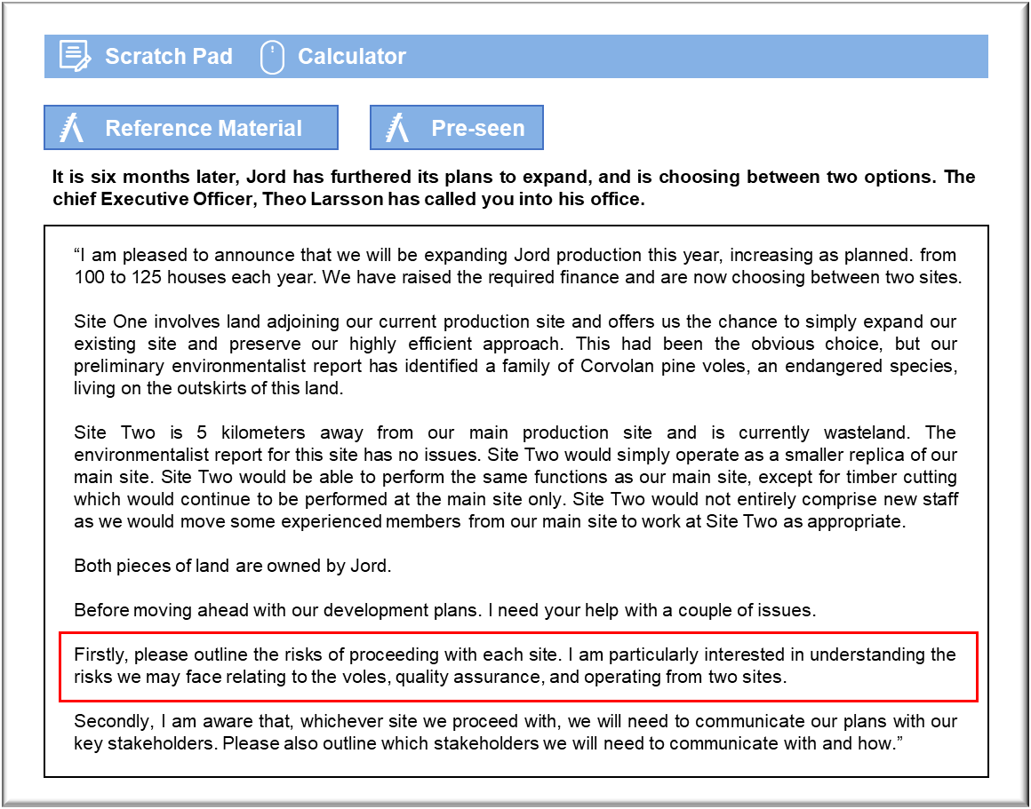

MANAGEMENT CASE STUDY MAY 2019 EXAM ANSWERS

Variant1 Task2
These answers have been provided by CIMA for information purposes only. The answers created are indicative of a response that could be given by a good candidate. They are not to be considered exhaustive, and other appropriate relevant responses would receive credit.

CIMA will not accept challenges to these answers on the basis of academic judgement.

Risks of proceeding with each site
Site One
The voles
As you know, at Jord we pride ourselves on our desire to care for the environment.
Choosing this site, this would really damage our reputation and brand on this front.
Even by doing everything we could to rehome the voles in as caring and safe way as
possible, we are still likely to experience bad publicity for our actions. In our risk
register, the environment risk, after mitigation, is already at a medium level and this is
only going to increase if we pursue this site.
There is also a risk that some of our staff will become disillusioned and demotivated, as
at least some of our staff are likely to be working for us because of our caring approach
to the environment. Quality of staff is a perceived risk, according to our register.
Losing key staff over this issue would only add to this risk which is already deemed to
be high.
Planning laws are another risk that we have currently highlighted. At the moment, this
is seen as low risk. However, it is likely to take longer to get agreement from the
planning authorities to enable us to begin work on this site, as they will clearly want us
to prove that we have a satisfactory method for rehoming the voles and they are likely
to be bombarded with protests from environmentalist groups. This can only lead to an
increase in risk to at least medium.
There is also a risk that the cost of rehoming the voles will eat into the likely return
from our investment.
There are, however, upside risks to us choosing this site. As this is the same site as our
current operations, there will be no additional costs of moving materials and part?finished timber work to the other site and it should be easier for us to maintain target
stock levels and efficiencies.
Site Two
Operating from two sites
Working across two sites, even though they are only 5 km apart, will make it more
difficult to use our current efficient approach in the production and supply processes.
It will be more complicated, at least in the short term, to co-ordinate operations and
some of our processes may involve duplication over the two sites given that Site Two
will effectively be a smaller replica of our main site. This would, of course, adversely
impact on the efficiency of our operating processes, although some of this could be
mitigated over time.
There are likely to be increased costs of operating over two sites due to issues with
logistics. We know that the timber cutting function will remain at Site One so at the
very least there is the question of how cut timber will be transported between the two
sites and how this will potentially impact on time schedules and quality.
Quality assurance
By transporting timber between the two sites it increases the risk that it will be
damaged or delayed in transit, all of which will impact on the way Jord organises its
May 2019 5 Management Case Study Exam
work. From a quality assurance perspective, we will need to ensure that the quality
control team working at the new site are trained to the same level as those at the
original site as this is a fundamental part of ensuring we produce a high quality,
reliably luxurious house product.
There is an upside risk, however, with choosing this site in that we would preserve or
enhance our reputation by publicising the fact that we have chosen this option and we
didn’t want to disturb the voles from their natural habitat.
Communicating expansion plans with stakeholders
There are several stakeholders that will be interested in the expansion plans and will,
therefore, need to be communicated with.
Shareholders will be most interested in the expansion plans. There are few
shareholders in this business and, so, communication with them should not be
difficult. Some of the shareholders are members of the Larsson family and those who
work in the business are likely to already be aware of the plans. All shareholders should
be contacted with details of the planned expansion. This might most effectively be
done via a shareholders meeting or letter, outlining the rationale behind expansion and
why management think it would be good for the business.
Staff will also be extremely interested in the expansion plans and will need to be made
aware of the plans and how they are impacted upon at work. Although we won’t be able
to fill in all the details of exactly how roles will change at this point, we will be able to
give staff an idea of their initial plans, particularly with regards to recruiting new staff
and how training and managing those staff will be approached.
Suppliers will need to be informed of the plans, particularly as Jord has a close
relationship with suppliers, working on a just-in-time basis and utilising seamless
connections with suppliers to get the flow just right. Initial conversations should
involve understanding whether suppliers will be able to continue to meet demand at a
higher level and include early discussions about how Jord and its suppliers may
continue to work closely together to preserve the excellent systems of production at
higher quantities.
Environmentalist groups and the local media will also be interested in our
plans, particularly if we pick Site One for our expansion. We will need to carefully
explain how the impact on the environment will be managed and how the Corvolan
pine voles will be safely rehoused. Good communication is essential here to prevent
protests from the environmentalists and any damage to our reputation. One
appropriate communication technique for this information may be a press release.

